

Journal of Geophysical Research Space Physics

Supporting Information for

Reply to Comments on “A Study of the F2 Layer Stratification on Ionograms Using a Simple Model of TIDs”

Chunhua Jiang1*, Guobin Yang1, Jing Liu2, Zhengyu Zhao1

1School of Electronic Information, Wuhan University, 430072, Wuhan, Hubei, China.

2Institute of Earthquake Science, China Earthquake Administration, 100036, Beijing, China.

*Corresponding author: Chunhua Jiang. Email: chuajiang@whu.edu.cn

**Contents of this file**

Tables S1， Figure S1

**Additional Supporting Information (Files uploaded separately)**

**data.zip**

The file of data.zip includes ionograms (*.amp)

**Introduction**

This supporting information provides the ionograms used in this study.

The files of *.amp are corresponding to ionograms data.

The file format of *.amp is shown in Table S1, readers could read them instructed by Tables S1. It is noted that the time of ionograms data is Beijing Time (Local Time=Beijing Time -1 hour).

Table S1.File format of *.amp recorded by ionosonde

|  |  |  |  |  |
| --- | --- | --- | --- | --- |
| Bytes | Description | Unit | Range | Type |
| 1-4 | Start frequency | MHz | 0-20 | float |
| 5-8 | Step frequency | KHz | 0-1000 | float |
| 9-12 | Stop frequency | MHz | 0-20 | float |
| 13-16 | Sounding times of each frequency | time | 1-128 | float |
| 17-20 | Total Range number of echoes | one | 1-700 | float |
| 21-24 | Range resolution | km | 3.84, 3.84*n,n=1,2.. | float |
| 25-28 | Number of frequency | one | 1-1000 | float |
| 29-32 | Echo starting position | one | 1-20 | float |
| 33-36 | Type of sounding code | - | 1:complementary code; otherwise: m sequence | float |
| 37-40 | Code order | one | 1-20 | float |
| 41-44 | Pulse width | one | 1-20 | float |
| 45-48 | Pulse repetition period | second | 1-1000 | float |
| 49-52 | Start year | year | 0-2999 | float |
| 53-56 | Start month | month | 1-12 | float |
| 57-60 | Start day | day | 1-31 | float |
| 61-64 | Start hour | hour | 0-24 | float |
| 65-68 | Start minute | minute | 0-59 | float |
| 69-72 | Start second | second | 0-59 | float |
| 73-76 | Stop year | year | 0-2999 | float |
| 77-80 | Stop month | month | 1-12 | float |
| 81-84 | Stop day | day | 1-31 | float |
| 85-88 | Stop hour | hour | 0-24 | float |
| 89-92 | Stop minute | minute | 0-59 | float |
| 93-96 | Stop second | second | 0-59 | float |
| 97-100 | Latitude of station | degree | 0-90 | float |
| 101-104 | Latitude of station | minute | 0-59 | float |
| 105-108 | Latitude of station | second | 0-59 | float |
| 109-112 | North and south latitude | - | 0:north; 1:south | float |
| 113-116 | Longitude of station | degree | 0-180 | float |
| 117-120 | Longitude of station | minute | 0-59 | float |
| 121-124 | Longitude of station | second | 0-59 | float |
| 125-128 | East and west longitude | - | 0: east; 1: west. | float |
| 129-132 | Code width | one | 1-100 | float |
| 133-136 | Mode of sounding | - | 0: sweep frequency sounding; 1: fixed frequency sounding; 2: hop frequency sounding. | float |
| 137-140 | Display Range number of echoes | one | 1-700, indicates number of echoes to be displayed on ionogram. | float |
| 141-144 | Type of sounding | - | 0: vertical sounding; 1: backscatter sounding; 2: oblique sounding. | float |
| 145-500*4 | Reserved | - | - | - |
| 500*4+1-end | data | - | - | float |

Data Set S1. data.zip

The file of data.zip includes ionograms (*.amp)

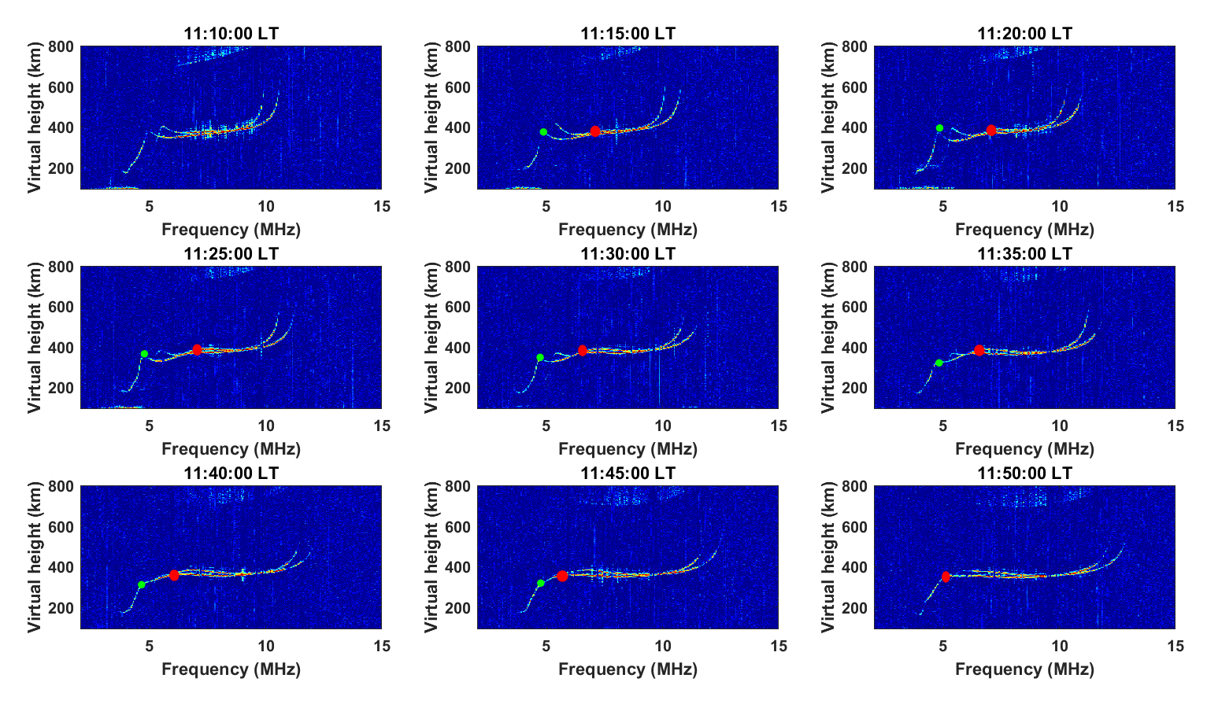

Figure S1. Time series of ionograms with the F2 layer stratification at Puer station on 17 September 2016. The red spot indicates the new cusp, and the green spot represents the critical frequency of the F1 layer.